

**Operating System**

**Lab # 10**

**Name: Zainab Bibi**

**Sap Id: 46462**

**Batch: BSCS 5thsemester**

**Submitted to: Mam Kausar**

**Lab Tasks:**

**Exercise 1:**

Put this code in a file and executes with two arguments.

echo “The following is the output of $0 script:”

echo “The total number of command line argument:$#”

echo “The first parameter:$1”

echo “The second parameter:$2”

**Solution:**

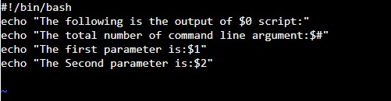



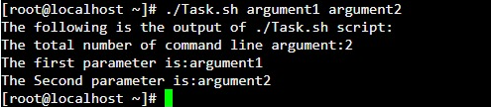

**Exercise 2:**

Write a program to take value from user between 1 to 5.and display result like this:

1. …you pressed 1
2. …you pressed 2

Above 5….invalid

**Solution:**

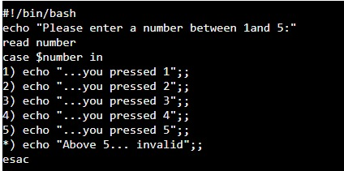

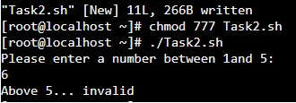

**Exercise 3:**

There are three semesters in an academic year i.e. Fall (Aug-Jan), Spring (Feb-May) and Summer (Jun-July). Write a script which read current month from the user and determine running semester. For example if user enters current month either 1 or January or Jan the script should display “Fall Semester”.

**Solution:**

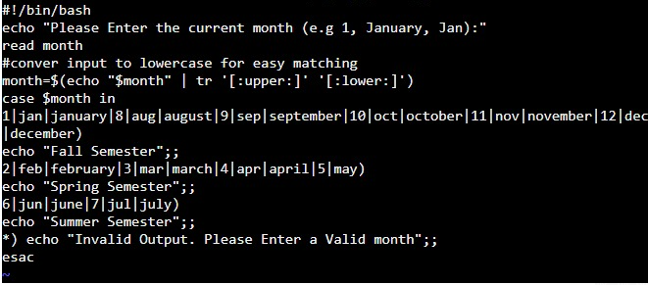

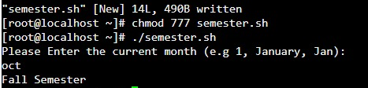

**Exercise 4:**

Write a program in shell scripting and attached screenshots with explanations

1. Perform array and string code in shell scripting
2. Perform If Else code in Shell Scripting
3. Perform Case related code in shell scripting

Hhhhh

**Array Code:**

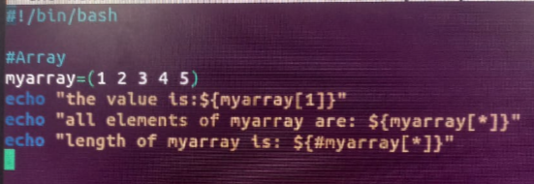

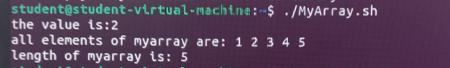

**String code:**

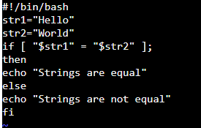

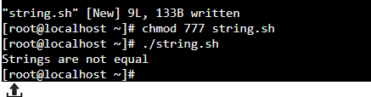

**IF Else Code:**





**3. Case Related:**

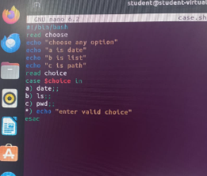

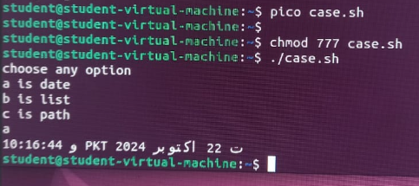

**THE END**